**CYCLE 1**

**PROGRAM 1**

**Aim** : Program to print greetings message

**Source code :**

first_name=input("Enter your first name :")

second_name=input("Enter your second name :")

print(f"Greetings !!! {first_name} {second_name}")

**Output :**

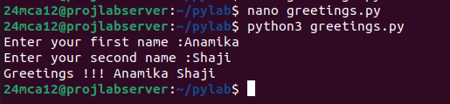

**________________________________________________________________________________**

**PROGRAM 2**

**Aim :** Program to demonstrate diffrent number datatypes

**Source code :**

int_num=10

float_num=10.5

complex_num=2+3j

print(f"Integer : {int_num} , Type : {type(int_num)}")

print(f"Float : {float_num} , Type : {type(float_num)}")

print(f"Complex : {complex_num} , Type : {type(complex_num)}")

**Output :**

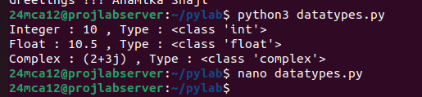

**PROGRAM 3**

**Aim :** Program to calculate area of circle

**Source code :**

radius=float(input("Enter the radius of the circle :"))

area=3.14*radius**2

print(f"The area of circle with radius {radius} is {area}")

**Output :**

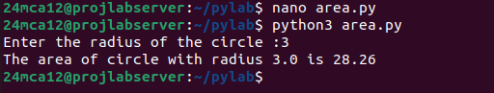

**________________________________________________________________________________**

**PROGRAM 4**

**Aim :** Program to calculate the salary of an employee

**Source code :**

basic_pay=float(input("Enter the basic pay :"))

hra=0.10*basic_pay

ta=0.05*basic_pay

total_salary=basic_pay+hra+ta

print(f"HRA={hra}\nTA={ta}\nThe total salary is : {total_salary}")

**Output :**

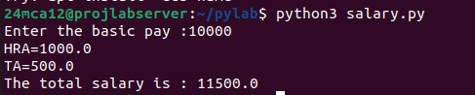

**PROGRAM 5**

**Aim :** Program to perform arithmetic operations on 2 integers

**Source code :**

num1=int(input("Enter first number :"))

num2=int(input("Enter second number :"))

print(f"Addition : {num1+num2}")

print(f"Substraction : {num1-num2}")

print(f"Multiplication :{num1*num2}")

print(f"Division :{num1/num2}")

print(f"Modulus :{num1%num2}")

**Output :**

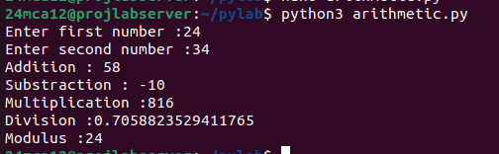

**________________________________________________________________________________**

**PROGRAM 6**

**Aim :** Program to print n copies of a given string

**Source code :**

string=input("Enter a string:")

n=int(input("Enter a non negative integer:"))

result= string*n

print(f"The result : {result}")

**Output :**

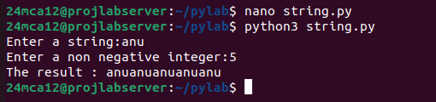

**PROGRAM 7**

**Aim :** Program to accept an integer and compute n+nn+nnn

**Source code :**

n=int(input("Enter a integer :"))

result=n+(n*10+n)+(n*100+n*10+n)

print(f"Result :{n}+{n}{n}+{n}{n}{n}={result}")

**Output :**

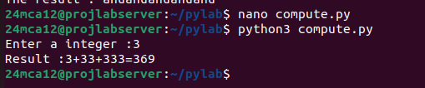

**________________________________________________________________________________**

**PROGRAM 8**

**Aim :** Program to find biggest of 3 numbers

**Source code :**

num1=int(input("Enter first number :"))

num2=int(input("Enter second number :"))

num3=int(input("Enter third number :"))

if num1>num2 & num1>num3:

print(f"{num1} is biggest.")

elif num2>num3:

print(f"{num2} is biggest.")

else:

print(f"{num3} is biggest.")

**Output :**

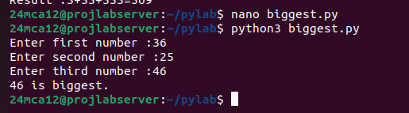

**PROGRAM 9**

**Aim :** Program to determine whether a year is leap year or not

**Source code :**

year=int(input("Enter the year :"))

if(year%400==0) or (year%100!=0 and year%4==0):

print(f"{year} is a leap year.")

else:

print(f"{year} is not a leap year.")

**Output :**

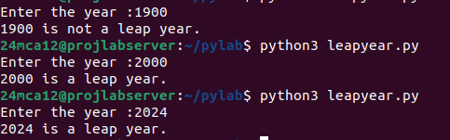

**________________________________________________________________________________**

**PROGRAM 10**

**Aim :** Program to determine the rate of entry ticket in a trade fair based on age.

**Source code :**

age=int(input("Enter your age :"))

if age<10:

rate=7

elif age>=10 and age<60:

rate=10

else:

rate=5

print(f"The rate of entry ticket is {rate}.")

**Output :**

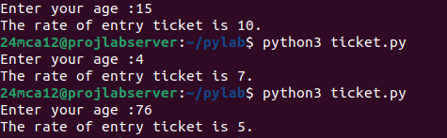

**PROGRAM 11**

**Aim :** Program to solve a quadratic equation

**Source code :**

import math

a=float(input("Enter coefficient of a :"))

b=float(input("Enter coefficient of b :"))

c=float(input("Enter coefficient of c :"))

d=b**2-4*a*c

if d>0:

root1=(-b+math.sqrt(d))/(2*a)

root2=(-b-math.sqrt(d))/2*a

print(f"The roots are real and different : {root1} {root2}")

elif d==0:

root=-b/(2*a)

print(f"The roots are real and same :{root}")

else:

real=-b/(2*a)

imaginary=(math.sqrt(-d))/(2*a)

print(f"Equation has Two complex roots {real}+{imaginary}i and {real}-{imaginary}i")

**Output :**

